Home Page

Karabo Holdings enables businesses to optimize their efficiency.

Our wide range services outside businesses non-core activities enable them to focus on their core operations.

We are unique. We offer combined services across different spectrum for our clients benefit.



**Karabo Holdings**

About us

We are unique. We offer combined services across different spectrum for our clients benefit

Management

Karabo Manyaka - Managing Director



Karabo Manyaka, a Graduate from London School of Business and Management, and an associate member of the British Computer Society - Charted Institute of Information Technology. He is passionate about service delivery and customer satisfaction with more than 9 years’ experience across the spectrum.   
  
He has experience in managing technical teams and has worked in the following verticals:

•Telecommunications   
•Broadcasting  
•IT Services  
•Financial Services (Banking & Insurance)   
  
He is a highly enthusiastic and goal driven individual.

Services

We offer a variety of services ranging from the following:

* **Shuttle Services**
* **Cleaning & Gardening Services**
* **Protection Services**
* **Catering Services**
* **Professional/Consulting Services**

When you click on the Services they should take you to Services Pages Below:



Shuttle Services



We currently provide shuttle Services across the Gauteng province, and provide airport shuttle services in Johannesburg.

We also offer Gautrain Station Transfers – From home to the station

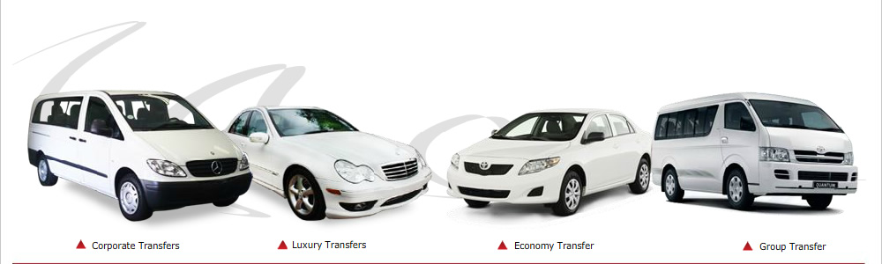

**For a quick quote: 0795377424 or** [**Service.KaraboHoldings@gmail.com**](mailto:Service.KaraboHoldings@gmail.com)

**We also offer standard rates for busy routes**



Cleaning Services & Gardening Services

 

Our cleaning & Gardening division is the fastest growing cleaning provider, this growth is the result of contentious investment in drivers of quality, technology innovation and old fashioned hard work.

Contact us and we will tailor the best deal that suit the needs of your business.





Protection Services



We provide safe secure workplaces for the corporate, commercial, retail and industrial sectors. Our ability to integrate security into our single source solutions empower business to focus on their core complete peace of mind.





Catering Services



For all your catering needs for small to medium corporate and personal events. We are here to offer you the best service.

We over a variety of menus that will be tailored for your event.





Professional/Consulting Services



Site under construction

Contact us

Tel: 0795377424

Visit us on: [www.karaboholdings.co.za](http://www.karaboholdings.co.za)

Email us: [Service.KaraboHoldings@gmail.com](mailto:Service.KaraboHoldings@gmail.com)

FAQ